County Championships 2021

Returning after a year off for COVID-19, the Kent County Championships returned to Bromley Tennis Centre for the 91st Championships between 23rd and 29th August 2021. Another great week of tennis was had with another County Championships t-shirt (grey this year) to add to the collection.

Despite slightly reduced numbers, attributed to the pandemic, the event took place over 7 days using 10 courts at BTC with 292 players and 543 entries in events from 8U to Open age groups competing in the tournament. A record entry in a number of events including the Mens Singles (51 entries) being played in the late afternoon/early evenings. 679 matches, 1,222 sets and 8,142 games were played throughout the week.

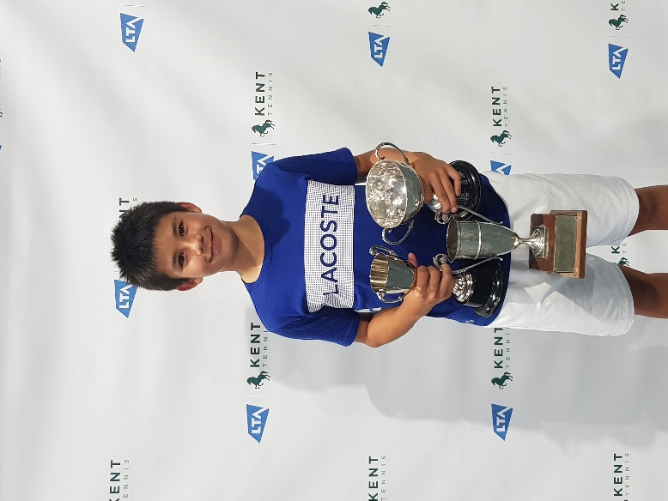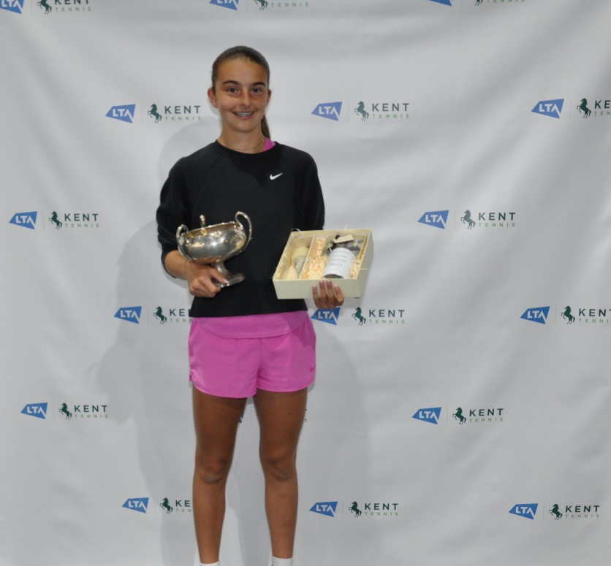

Congratulations to Ben and Lois who were both crowned Junior Singles Champions and Mens/Ladies Singles for 2021; they both won their three finals. Congratulations also go to Eloise who reached four finals and Chloe, Niamh, and Matthew all reached three.

2021 saw the introduction of qualifying events taking place, which saw another 44 entries taking to the courts prior to the County Championships with the winners gaining a space in the main draw. The purpose of the qualifying events is to ensure appropriate and enjoyable opportunities for those newer to competition. We look forward to working with local organisers further to make these events a success in 2022.

Thank you to the Kent Office Team (Harri, Janice and Phil) as well as Keeley Wicks, for manning the Welcome Desk throughout the week, Bromley Tennis Centre for providing the facility and managing the event, Lisa Field and The Brunch Shop team for keeping us fed and to the tournament team of Graham Silvester, Chris Mann and Jason Baker for organising a great week.

Planning is already underway for the 2022 event!

